1. **Question:**

What is the advantage of using priority queue in comparison with other scheduling algorithms you have learned?

* Processes with higher priority execute first which saves time.
* This provides a good mechanism where the relative importance of each process may be precisely defined.

1. **Result:**

**2.1)**

Our first test case is:

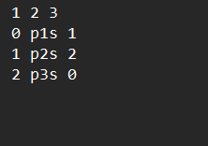

` And the result and Gantt diagram is:

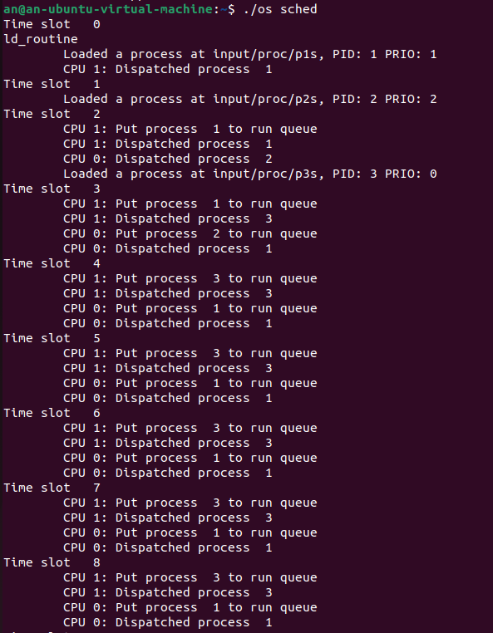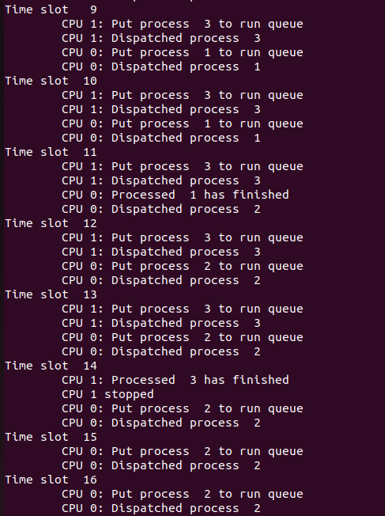

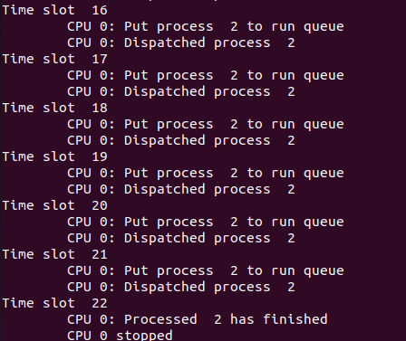

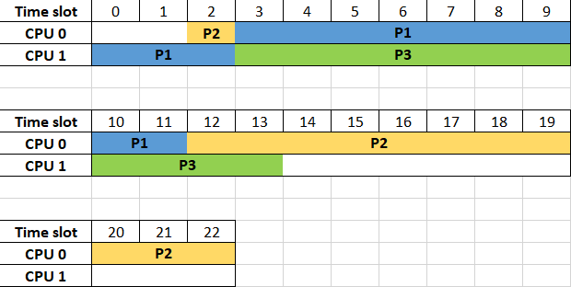

Process 3 has highest priority than 1 and 2, so when it comes, CPU 1 will execute it instead of process 1. This also happens to CPU 0, it will execute process 1 instead of 2. And when process 1 or 3 finish, process 2 will be executed.

**2.2)**

We will use os_1_mlq_paging as the second test case:

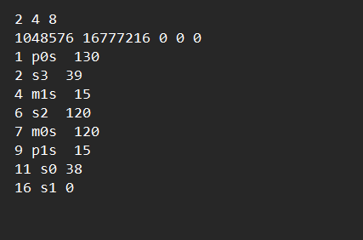

The result and Gantt chart is:

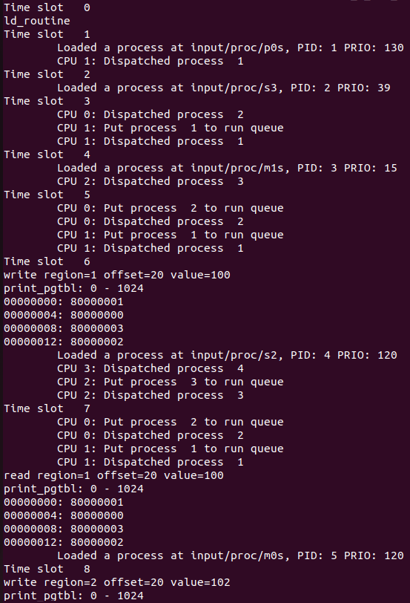

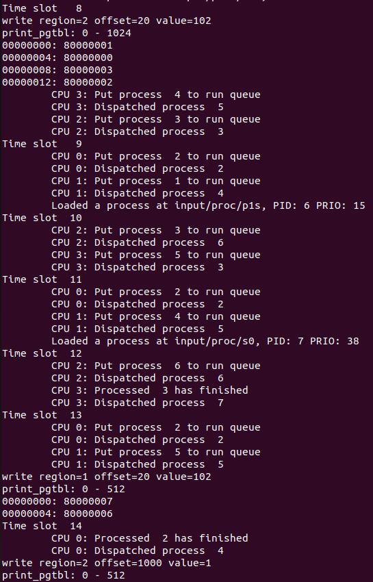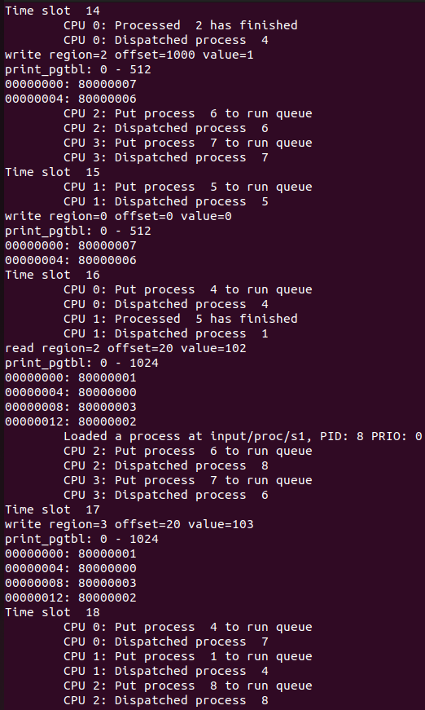

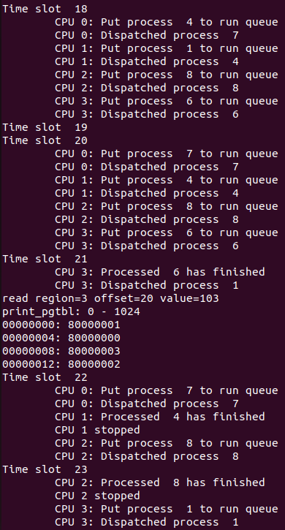

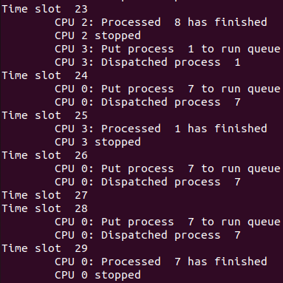

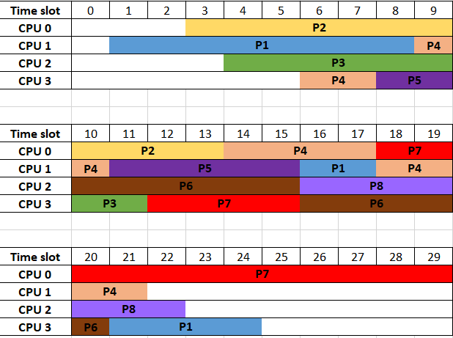

In this test case, we use 4 CPU so 4 processes with highest priority will be executed concurrently as you can see in the Gantt diagram.